**LAB 5**

How do you declare an empty map in Dart?

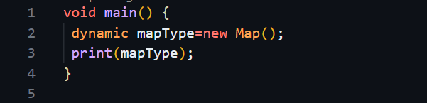

1. Provide an example of initializing a map with key-value pair

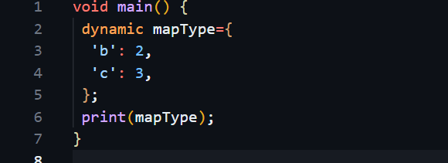

3)How do you access the value associated with a specific key in a Dart map?

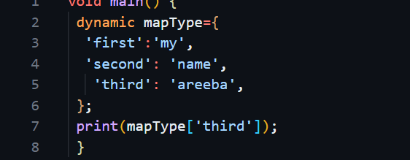

4) Explain how to add a new key-value pair to a Dart map.

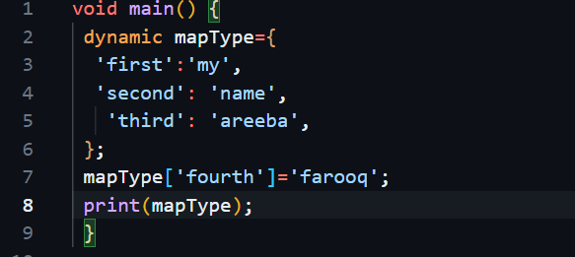

What is the length property of a Dart map?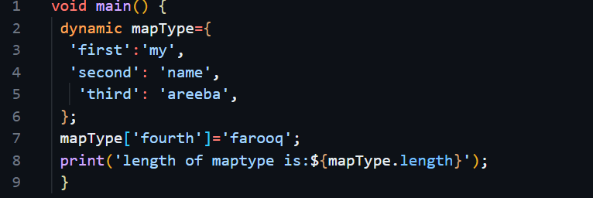

1. Declare two variables, a and b, with values 15 and 7 respectively. Print their sum.

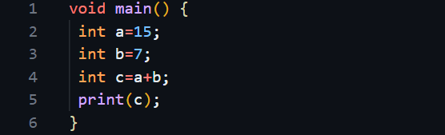

Declare two variables, x and y, with values 10.5 and 3.2 respectively. Print their

product.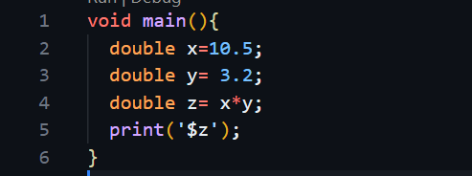

Declare a variable num with a value of -8. Print its absolute value.

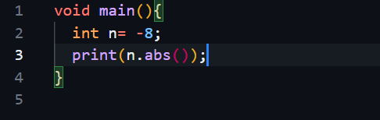

Declare a variable decimalNum with a value of 7.3. Print its ceiling and floor values

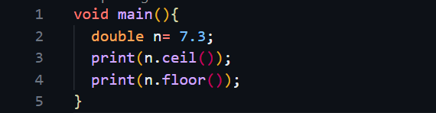

Compare the values of a and b. Print whether a is greater than b.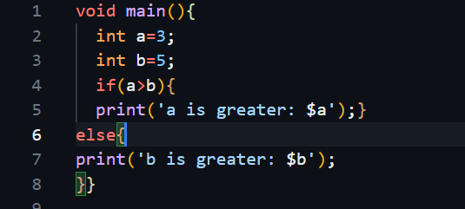

Declare an empty set named mySet in Dart

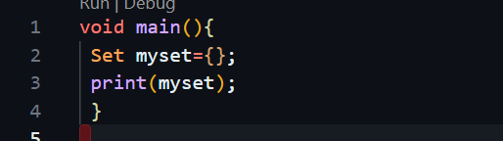

Add the numbers 10, 20, and 30 to the set